**Supplementary Materials**

**Adult Pilot Study**

The prediction of the NN model that training including only the prototype will increase correct categorization and generalization in the children who show atypical generalization with variable training examples is quite novel. The category learning literature predicts that when people are having trouble generalizing they benefit from more variable training examples. It has been known for over a quarter of a century that adults show better learning and generalization when they learn categories from multiple variable training exemplars rather than a few good examples (e.g., Homa, Sterling, & Trepel, 1981). This benefit of variable training for category generalization has also been shown in a number of studies with typically developing children of various ages. School-age children show advantages for variable examples in visual sorting tasks (e.g., Hayes & Taplin, 1993). Infants show greater generalization and learning with variable examples in visual learning of natural categories (e.g., Kovack-Lesh & Oakes, 2007), and toddlers consistently show an advantage for category generalization and category labelling with variable examples (e.g., Perry, Samuelson, Malloy, & Schiffer, 2010; Twomey, Ranson, & Horst, 2014). Given all of these examples of greater generalization with variable training in both adults and children, typical children, and adults should show reduced generalization after training with only the prototype as compared to training with variable examples. The NN model predicts that A Type 1 children with HFASD will also show this pattern, but that A Type 2 children will show increased learning and generalization when trained with only the prototype. To pilot our tasks to be sure that the particular stimuli and task would produce the normative reduced generalization after Prototype-Only training typically seen in adults and children, we initially ran the exact tasks used with the children with HFASD with college students.

*Participants.* Fifty-one undergraduates from the University of Buffalo participated for partial fulfillment of their introductory psychology course requirements. Seven participants were excluded for using one response more than 75% of time. Two participants were excluded because of experimenter error, and one was dropped for having more than 10 missing values. Finally eight participants were randomly dropped to equate counterbalancing conditions. Thirty-two adults were included in the final data analyses*.* All stimuli, materials, procedure, and design elements were exactly the same as in the experiment run with the children except they only did one experiment, and it was run on desktop computers at the University, instead of laptop computers at the treatment program.

# **Results**

A (2 X 7) GLM using the proportion of category endorsements as the dependent measure, and Training (Distortion, Prototype Only) and Stimuli (prototype, L2, L3, L4, L5, L7, random) as the within participant variables found significant main effects of Training, *F*(1,31) = 10.70, *p = .*003, *ηp2* = .26, and Stimuli, *F*(6,186) = 67.33, *p < .*001, *ηp2* = .69, reflecting greater overall endorsements after distortion training, and more endorsement of less distorted stimuli. The interaction between Training and Stimuli was also significant, *F*(6,186) = 6.45, *p = .*001, *ηp2* = .17, reflecting the reduced generalization seen after prototype only training (See Figure S1).

***Figure S1****. Proportion of category endorsements across stimulus type after Distortion and Prototype Only training. Error bars depict standard error of the means.*

**Criterion for Inclusion in the HFASD Sample**

All the children in this study were recruited from a summer psychosocial intervention treatment program specifically designed for school age children with high functioning autism spectrum disorder (HFASD). Children completed a series of tests as part of the application process for the program and only children with a Wechsler Intelligence Scale for Children-4th Edition (WISC-IV, Wechsler, 2003) short-form IQ composite > 70 (and a major index score {VCI or PRI} > 80); receptive or expressive language score > 80 on the Comprehensive Assessment of Spoken Language (CASL short form, Carrow-Woolfolk, 1999), and a score meeting ASD criteria on the Autism Diagnostic Interview-Revised (ADI-R, Rutter, LeCouteur, & Lord, 2003) were included in the program. All the children at the summer treatment program during the time of testing participated in the experiment. The sample size was determined by number of children available given the recruitment site and days of testing.

**Stimuli Construction**

Random dot shapes are modifications of random dot patterns. The specific algorithms used to create these shapes have been used in multiple experiments and their properties and perceived similarity are well understood (e.g., Church et al, 2010; Posner & Keele, 1968; Smith Redford & Haas, 2008).They are generated by affixing nine points within a 30x30 pixel central area of a 50x50 pixel area.

Varying levels of distortion are created by changing the probability that each dot moves within a five area space. In Area 1, a dot keeps its original position. In Area 2, a dot moves to one of the 8 pixels immediately surrounding the original dot. In Area 3, a dot moves to a position on the 16 pixel shell around the previous 8. In Area 4, a dot moves to one of the positions on the third, fourth, and half of the fifth pixel shell around Areas 1-3. In Area 5, a dot moves to one of the remaining 300 pixels in a 20x20 peripheral grid outside of Areas 1-4. The probability that the dots of the prototype (distortion level 0) stay in area 1 is 1.0. See Table S1 for the remaining location probabilities.

**Table S1.** Dot location probabilities for each distortion level.

|  |  |  |  |  |  |
| --- | --- | --- | --- | --- | --- |
| Distortion Level | Area 1 | Area 2 | Area 3 | Area 4 | Area 5 |
| 2 | .75 | .15 | .05 | .03 | .02 |
| 3 | .59 | .20 | .16 | .03 | .02 |
| 4 | .36 | .48 | .06 | .05 | .05 |
| 5 | .2 | .3 | .4 | .05 | .05 |
| 7 | 0 | .24 | .16 | .3 | .3 |

The patterns were magnified three times by mapping each point into the center of a 3x3 pixel area, so that a pattern originally represented in a 50x50 pixel area was displayed in an area of 150x150 pixels. Shapes were created from the random dot patterns using the DrawPoly procedure in Turbo Pascal 7.0 to join successively created dots with lines. Lastly, this program added a variety of colors to fill the shapes.

Random patterns were created by random placement of nine dots in the 50x50 pixel area. Using identical procedures, the Random patterns were enlarged, joined, and colored (See Figure S2 for example stimuli).***Figure S2.***  *Stimulus Set B: A. Category-members shown during training. B. Non-category-members shown during training.* *C. Category-members shown during testing. D. Non-category-members shown during testing.*

A.

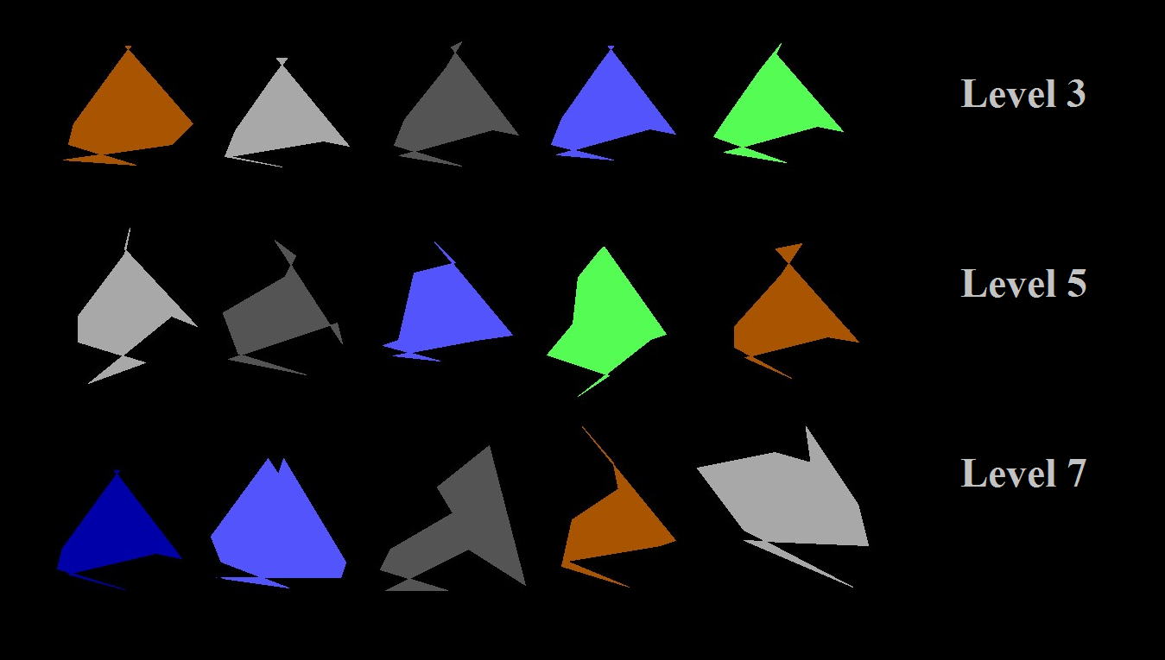

B.

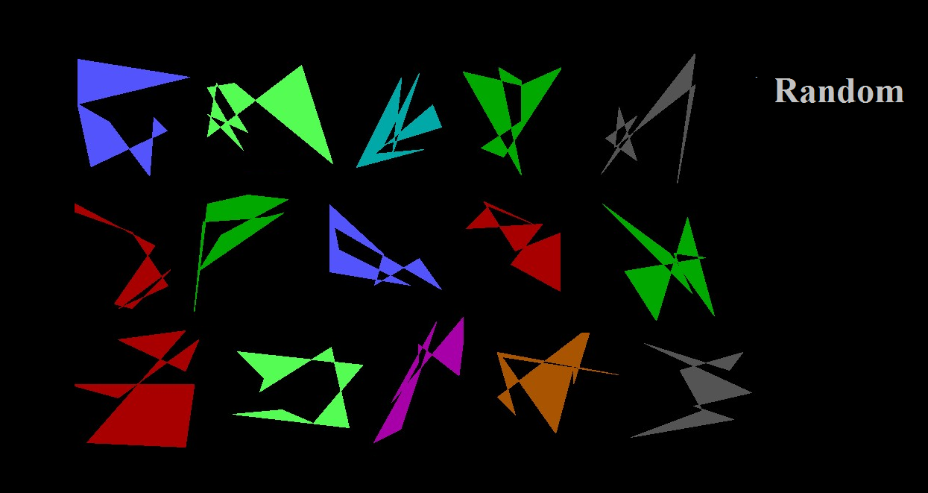

C.

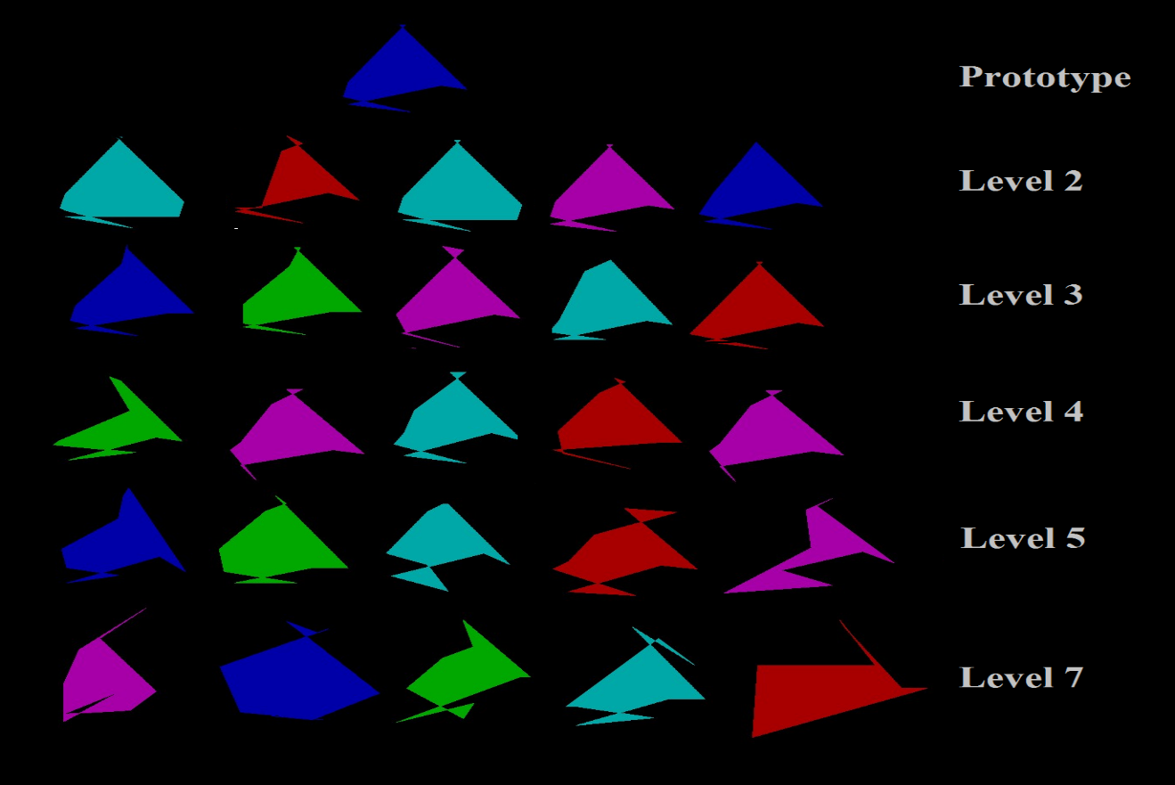

D.

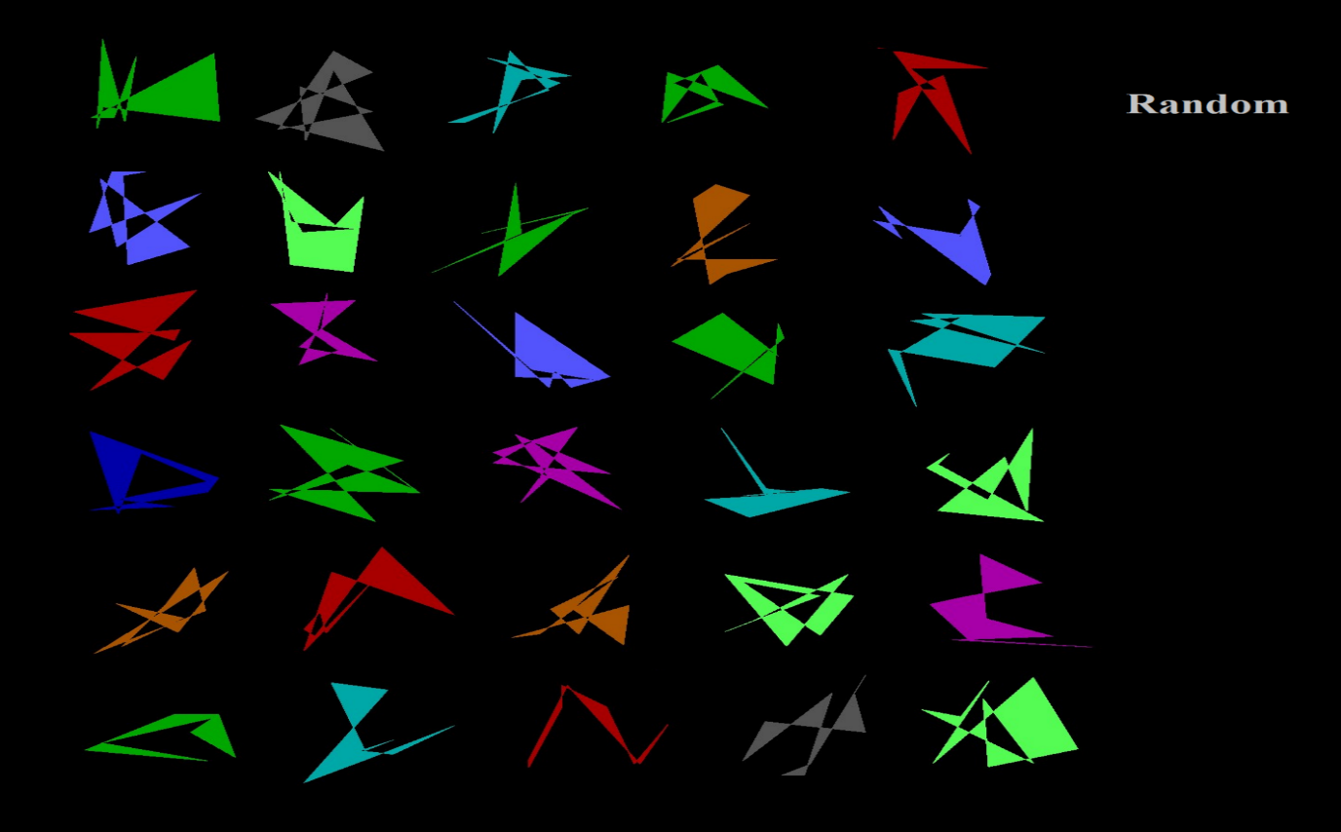

**The Prototype Model**

The prototype model assumes comparisons between to-be categorized items (TBCIs) and a summary representation of the category (e.g., a prototype). Our TBCI types include the prototype, L2, L3, L4, L5, L7 distortions, and Random shapes. Psychological similarity between TBCIs *(i)* and the prototype *(p)* are estimated by the model in order to predict the strength of category endorsement for each. The values for the model equation below follow. RCat = Category Response, S*i* = Given Item Type, = Psychological Similarity, and *k*= criterion quantity (a proportionalizing free parameter). In simple terms, the choice rule equation (A) below states the probability of category endorsement, given the TBCI type:

**(A)** *P*(RCat| S*i*) = __*ip__*

*ip* + *k*

To calculate psychological similarity ( the average Pythagorean distance that corresponding dots moved between patterns *(i)* and *(p)* was calculated. This measurement was set equal to the equation ln (1+ mean Pythagorean distance). One million samplings of each pair type were modeled to produce the values: 0.0000, 0.4497, 0.6401, 0.8687, 1.094, 1.762, and 2.8479 (average logarithmic distances between the prototype and the prototype, L2, L3, L4, L5, L7 distortions, and Random shapes respectively).

Psychological similarity has an exponential-decay function of the psychological distance. A sensitivity parameter controlled the steepness of the decay. Therefore, the distance measures above *(d)* were translated to psychological similarity measures, for all transfer item types, by using an exponential-decay function *(e)* and incorporating a second free parameter, sensitivity *(c)*, as shown below:

*ip* = *e-cdip*

Psychological similarity ( was entered into the choice rule (A) above, and the probability of endorsement was calculated for each type.

*Model Fitting*

Standard “hill-climbing” procedures found the best possible fits to the data. Hill-climbing procedures involve “seeding the model” in other words changing the criterion *(k)* and sensitivity *(c)* free parameters to produce the lowest deviation between the model predictions and actual observed performance.

During each instance of seeding, one parameter and a directional change were randomly applied, and new values replaced the old values if they produced a better fit. The directional changes were always very small (1/10,000,000 for criterion and 1/10,000 for sensitivity) and respected the upper and lower bounds of the free parameters (0.0000001 and .1 for criterion and .0001 and 10 for sensitivity). At least four hill-climbing attempts (using new configurations of free parameter values) were made for every item type, to ensure that local minima did not limit the model’s power. Once the best fit had been determined, the sum of the squared deviations between the model predictions and the observed values and the values of the sensitivity (*c*), and criterion (*k*) free parameters were recorded for each participant.

**References**

Carrow-Woolfolk, E. (1999). *Comprehension assessment of spoken language*. Circle Pines, MN: American Guidance Service.

Church, B. A., Krauss, M. S., Lopata, C., Toomey, J. A., Thomeer, M. L., Coutinho, M. V., & Mercado, E., III. (2010). Atypical categorization in children with high-functioning autism spectrum disorder. *Psychonomic Bulletin & Review, 17*, 862-868. doi: 10.3758/PBR.17.6.862

Hayes, B. K. & Taplin, J. E. (1993). Developmental differences in the use of prototype and

exemplar-specific information. *Journal of Experimental Child Psychology, 55,* 329-352.

[doi: 10.1006/jecp.1993.1019](http://dx.doi.org/10.1006/jecp.1993.1019)

Homa, D., Sterling, S., & Trepel, L. (1981). Limitations of exemplar-based generalization and

the abstraction of categorical information. *Journal of Experimental Psychology: Human*

*Learning and Memory, 7,* 418-439*.* [doi: 10.1037/0278-7393.7.6.418](http://dx.doi.org/10.1037/0278-7393.7.6.418)

Kovack, K. A., & Oakes, L. M. (2007). Hold your horses: How exposure to different items influences infant categorization. *Journal of Experimental Child Psychology, 98*, 69-93. doi:10.1016/j.jecp.2007.05.001

Perry, L. K., Samuelson, L. K., Malloy, L. M., & Schiffer, R. N. (2010). Learn locally, think globally: Exemplar variability supports higher-order generalization and word learning. *Psychological Science, 21*, 1894-1902. doi: 10.1177/0956797610389189

Posner, M.I., & Keele, S.W. (1968). On the genesis of abstract ideas. *Journal of Experimental*

*Psychology, 77*, 353-363. [doi: 10.1037/h0025953](http://dx.doi.org/10.1037/h0025953)

Rutter, M, LeCouteur, A., & Lord, C. (2003). *The Autism Diagnostic Interview- Revised (ADI-R).* Los Angeles, CA: Western Psychological Services.

Smith, J. D., Redford, J. S., & Haas, S. M. (2008). Prototype abstraction by monkeys (*Macaca mulatta*). *Journal of Experimental Psychology: General, 137*, 390-401. doi: 10.1037/0096-3445.137.2.390

Twomey, K. E., Ranson, S. L., & Horst, J. S. (2014). That’s more like it: Multiple exemplars facilitate word learning. *Infant and Child Development, 23*, 105-122. doi: 10.1002/icd.1824

Wechsler, D. (2003). *Wechsler intelligence scale for children* (4th ed.). San Antonio, TX: The

Psychological Corporation.